Asymmetric DCC correlation: GBPUSD and USDCAD
Method 10 / GARCH(1,1) + Cappiello-Engle-Sheppard ADCC / Alpari D1 full available history

Study setup
Logical pair: GBPUSD , USDCAD
Broker symbols: GBPUSD_i , USDCAD_i
Snapshot: 2026-11-03_majors_alpari_D1
Timeframe: D1
Matched return window: 1999-01-05 to 2026-11-02 (UTC bar dates)
Matched return count n: 7205
Dropped unfinished last bar dated 2026-11-03 UTC after a tick-volume check against the prior complete day.
GBPUSD GARCH(1,1): mu=0.000021, omega=0.003975, alpha=0.054995, beta=0.932736
USDCAD GARCH(1,1): mu=-0.000005, omega=0.001251, alpha=0.043587, beta=0.951299
ADCC: a=0.014822, b=0.982587, g=0.001036, a+b+g/2=0.997927
Nested DCC (g=0): a=0.014757, b=0.982838
Negative shock: n = min(z, 0) in broker quote direction (not inverted)
Burn-in ignored in path summaries and chart: first 60 updates
Complete matched rows (Excel): GBPUSD-USDCAD_ADCC_D1.xlsx
Complete matched rows (HTML table): GBPUSD-USDCAD_ADCC_D1_data.html

Method carried forward
Asymmetric DCC extends Engle DCC with an extra term on joint negative standardised shocks. Each matched daily log return of close, ln(close_t / close_t-1), is first filtered by a constant-mean GARCH(1,1). Then z = residual / sigma and n = min(z, 0). The Cappiello-Engle-Sheppard recursion uses A = (1-a-b) Q_bar - g N_bar with N_bar = mean(n n'). Quotes are not inverted, so a negative shock is a negative log return in the broker quote. Nested symmetric DCC (g = 0) is fit on the same z path for comparison. Constraints: a,b,g >= 0 and a + b + g/2 < 1. Path summaries ignore the first 60 updates. The headline is latest ADCC rho. Pearson r is a side check only. This is not a cause, lead, or trading signal.

Results
Latest ADCC rho: -0.594171
Latest nested DCC rho: -0.588185
Post-burn-in ADCC path (n=7145): mean=-0.409339, median=-0.440459, min=-0.705065, max=0.127839, std=0.167792
Share of post-burn-in days with |rho| >= 0.4: 59.34%; |rho| >= 0.7: 0.03%
Same-sample Pearson r: -0.456462
ADCC minus r: -0.137709
ADCC minus nested DCC: -0.005986

Conclusion
Over 7205 matched daily log-return rows for GBPUSD and USDCAD (broker quote directions unchanged), latest ADCC rho is -0.5942 (negative, moderate conditional linear link in this sample) with fitted a=0.0148, b=0.9826, g=0.0010. Nested symmetric DCC latest rho is -0.5882 (ADCC minus DCC = -0.0060). After a 60-day burn-in, path mean is -0.4093 and std is 0.1678. Same-sample Pearson r is -0.4565 (ADCC minus r = -0.1377). This does not establish cause, lead-lag, or a lasting trading rule.

Charts
Daily closes

Daily log returns
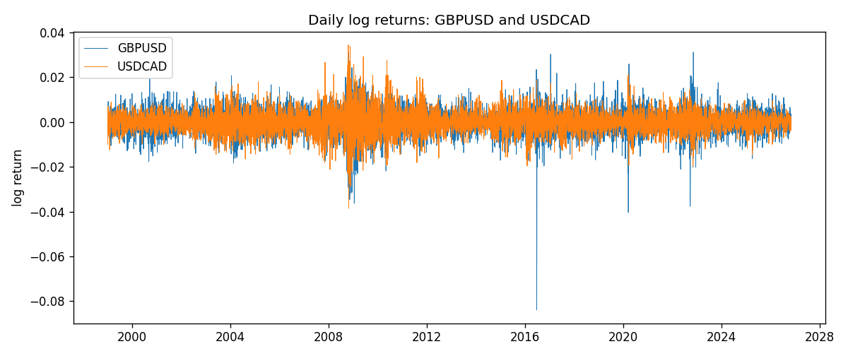
ADCC rho path with nested DCC and Pearson r
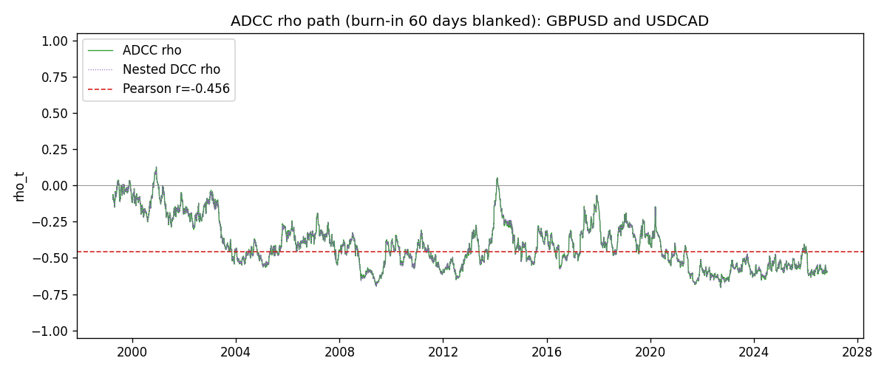

Data report
Every matched row that entered the ADCC recursion is stored in the sibling Excel workbook named GBPUSD-USDCAD_ADCC_D1.xlsx. Embedding all rows as a Word table is impractical at this length; the Word file holds the column list, column summaries, and the first and last 15 matched rows.
Columns: time, GBPUSD_open, USDCAD_open, GBPUSD_high, USDCAD_high, GBPUSD_low, USDCAD_low, GBPUSD_close, USDCAD_close, GBPUSD_tick_volume, USDCAD_tick_volume, GBPUSD_spread, USDCAD_spread, GBPUSD_real_volume, USDCAD_real_volume, GBPUSD_log_return, USDCAD_log_return, GBPUSD_sigma, USDCAD_sigma, GBPUSD_z, USDCAD_z, GBPUSD_n, USDCAD_n, q11, q22, q12, rho_adcc, rho_dcc
Column summaries (matched calculation rows)
column | count | mean | std | min | 25% | 50% | 75% | max
GBPUSD_open | 7205 | 1.5161639 | 0.2182756 | 1.06854 | 1.32505 | 1.51142 | 1.63205 | 2.1066
USDCAD_open | 7205 | 1.2670469 | 0.16900802 | 0.9168 | 1.119 | 1.29857 | 1.3723 | 1.6183
GBPUSD_high | 7205 | 1.5224596 | 0.21884187 | 1.08366 | 1.32981 | 1.5182 | 1.6384 | 2.1161
USDCAD_high | 7205 | 1.2719479 | 0.16896591 | 0.9336 | 1.1234 | 1.30394 | 1.3769 | 1.619
GBPUSD_low | 7205 | 1.5098441 | 0.21750249 | 1.03518 | 1.31956 | 1.50336 | 1.62444 | 2.0983
USDCAD_low | 7205 | 1.2624879 | 0.16904619 | 0.9056 | 1.1144 | 1.29361 | 1.36793 | 1.6102
GBPUSD_close | 7205 | 1.5162333 | 0.21823062 | 1.06879 | 1.3252 | 1.5114 | 1.6322 | 2.1065
USDCAD_close | 7205 | 1.2670655 | 0.16898286 | 0.916 | 1.11851 | 1.29871 | 1.37253 | 1.6137
GBPUSD_tick_volume | 7205 | 94776.836 | 153518.92 | 62 | 9986 | 52867 | 91739 | 1273370
USDCAD_tick_volume | 7205 | 80835.261 | 147176.39 | 37 | 5509 | 40849 | 71515 | 1410818
GBPUSD_spread | 7205 | 26.978348 | 19.192834 | 0 | 11 | 20 | 50 | 50
USDCAD_spread | 7205 | 23.508952 | 18.282466 | 0 | 9 | 17 | 40 | 60
GBPUSD_real_volume | 7205 | 3.5541156e+09 | 8.441481e+10 | 0 | 0 | 0 | 0 | 2.4038164e+12
USDCAD_real_volume | 7205 | 1.8330194e+10 | 9.6578305e+10 | 0 | 0 | 0 | 0 | 2.5751613e+12
GBPUSD_log_return | 7205 | -2.188e-05 | 0.00563988 | -0.08388241 | -0.00312535 | 3.221e-05 | 0.0031749 | 0.03112653
USDCAD_log_return | 7205 | -1.219e-05 | 0.00514402 | -0.03859748 | -0.00283601 | 4.92e-05 | 0.00272763 | 0.03436319
GBPUSD_sigma | 7205 | 0.00539059 | 0.00169172 | 0.00300172 | 0.00447484 | 0.00503171 | 0.00576407 | 0.02192746
USDCAD_sigma | 7205 | 0.00479571 | 0.00181262 | 0.00250953 | 0.00365721 | 0.00435895 | 0.00535476 | 0.01852289
GBPUSD_z | 7205 | -0.00681184 | 1.0000225 | -10.32614 | -0.60097345 | 0.00239338 | 0.60673152 | 4.9475886
USDCAD_z | 7205 | 0.00156339 | 1.0000914 | -4.0699941 | -0.62903578 | 0.01123275 | 0.61274549 | 6.418043
GBPUSD_n | 7205 | -0.38646426 | 0.60946716 | -10.32614 | -0.60097345 | 0 | 0 | 0
USDCAD_n | 7205 | -0.38703658 | 0.58832858 | -4.0699941 | -0.62903578 | 0 | 0 | 0
q11 | 7205 | 1.0018308 | 0.16992313 | 0.5904731 | 0.91418277 | 0.98476121 | 1.0573251 | 2.9451304
q22 | 7205 | 1.0015933 | 0.13827215 | 0.6922542 | 0.91094103 | 0.98486412 | 1.068377 | 1.7630974
q12 | 7205 | -0.41152403 | 0.18721943 | -1.0829696 | -0.53249602 | -0.43862463 | -0.29810577 | 0.13464251
rho_adcc | 7205 | -0.40760025 | 0.16829789 | -0.70506537 | -0.54079848 | -0.43837779 | -0.30960559 | 0.12783895
rho_dcc | 7205 | -0.40744865 | 0.16804734 | -0.70644253 | -0.53953364 | -0.43774169 | -0.31077911 | 0.12468568
First 15 matched rows (selected columns)
time | GBPUSD_log_return | USDCAD_log_return | GBPUSD_z | USDCAD_z | GBPUSD_n | USDCAD_n | q11 | q22 | q12 | rho_adcc | rho_dcc
1999-01-05 | -0.0028966287 | -0.010131666 | -0.71548762 | -2.2378296 | -0.71548762 | -2.2378296 | 1 | 1 | -0.41194472 | -0.41194472 | -0.41194472
1999-01-06 | -0.00060452184 | -0.0003306769 | -0.15458315 | -0.066277754 | -0.15458315 | -0.066277754 | 0.99275636 | 1.0640794 | -0.38051952 | -0.37022743 | -0.37275734
1999-01-07 | -0.002118709 | 0.0015202092 | -0.54013389 | 0.31792121 | -0.54013389 | 0 | 0.9778997 | 1.0476972 | -0.37487005 | -0.37035285 | -0.3726218
1999-01-08 | -0.0058954193 | -0.0020495197 | -1.5132051 | -0.43445478 | -1.5132051 | -0.43445478 | 0.9675493 | 1.0330289 | -0.37202673 | -0.37211859 | -0.3741554
1999-01-11 | -0.0056851331 | -0.0035137769 | -1.4013078 | -0.75901184 | -1.4013078 | -0.75901184 | 0.98906428 | 1.020111 | -0.35626222 | -0.35467763 | -0.35760964
1999-01-12 | 0.0022657001 | 0.0066194721 | 0.53422863 | 1.4461799 | 0 | 0 | 1.0050329 | 1.0135606 | -0.33433081 | -0.33125421 | -0.33545169
1999-01-13 | 0.0091330396 | 0.0045420214 | 2.2008597 | 0.96949366 | 0 | 0 | 0.99381383 | 1.0289887 | -0.31819643 | -0.31465707 | -0.31854981
1999-01-14 | 0.0019376331 | 0.0069376546 | 0.41871555 | 1.48174 | 0 | 0 | 1.0503564 | 1.0270798 | -0.28216778 | -0.27166706 | -0.27526149
1999-01-15 | -0.0017558204 | -0.0056905671 | -0.39591343 | -1.182499 | -0.39591343 | -1.182499 | 1.0367165 | 1.0438157 | -0.26919714 | -0.2587787 | -0.26211468
1999-01-18 | 0.0012112405 | 0.00098344542 | 0.27051282 | 0.20390662 | 0 | 0 | 1.0232011 | 1.0498911 | -0.25822437 | -0.24914064 | -0.25289894
1999-01-19 | 0.0018745281 | 0.002748513 | 0.43056114 | 0.58002555 | 0 | 0 | 1.0085201 | 1.0343027 | -0.2540493 | -0.2487436 | -0.25226562
1999-01-20 | -0.0049053846 | -0.0059646885 | -1.1653375 | -1.2733447 | -1.1653375 | -1.2733447 | 0.99575779 | 1.0233561 | -0.24706283 | -0.24474688 | -0.24803521
1999-01-21 | 0.0031518998 | -0.0042823796 | 0.72985673 | -0.9014805 | 0 | -0.9014805 | 1.0020054 | 1.0333258 | -0.2203683 | -0.21656858 | -0.22151517
1999-01-22 | 0.0024781662 | 0.0025057712 | 0.57754476 | 0.53137762 | 0 | 0 | 0.99450447 | 1.0302968 | -0.22742245 | -0.22467191 | -0.22940305
1999-01-25 | 0.0012066366 | 0.00085579808 | 0.28250812 | 0.18511914 | 0 | 0 | 0.98418256 | 1.0186186 | -0.22005242 | -0.21977714 | -0.2242727
Last 15 matched rows (selected columns)
time | GBPUSD_log_return | USDCAD_log_return | GBPUSD_z | USDCAD_z | GBPUSD_n | USDCAD_n | q11 | q22 | q12 | rho_adcc | rho_dcc
2026-10-13 | 0.0036434319 | -0.0046395653 | 0.98760563 | -1.6058085 | 0 | -1.6058085 | 0.77479086 | 0.81937387 | -0.45361066 | -0.56931149 | -0.56320364
2026-10-14 | -0.0049164679 | 0.0015184751 | -1.3355659 | 0.50845408 | -1.3355659 | 0 | 0.77780797 | 0.8480751 | -0.47035788 | -0.57912869 | -0.57361694
2026-10-15 | 0.0065976411 | -0.0036101503 | 1.7279234 | -1.217041 | 0 | -1.217041 | 0.79460189 | 0.83921656 | -0.47337204 | -0.5796833 | -0.57453906
2026-10-16 | 0.0037592051 | -0.0034322068 | 0.92624632 | -1.1399196 | 0 | -1.1399196 | 0.82707234 | 0.85016911 | -0.49743907 | -0.59321959 | -0.58828969
2026-10-19 | -0.0017500314 | -0.0018835331 | -0.43789151 | -0.61804746 | -0.43789151 | -0.61804746 | 0.82743842 | 0.85804839 | -0.50556634 | -0.60000438 | -0.59517513
2026-10-20 | 0.0055923442 | -0.0037066008 | 1.4003793 | -1.2294277 | 0 | -1.2294277 | 0.81812227 | 0.85124172 | -0.49361011 | -0.59149147 | -0.58688787
2026-10-21 | 0.0012476328 | -0.00084691787 | 0.29865772 | -0.2752711 | 0 | -0.2752711 | 0.83499526 | 0.86246543 | -0.5116731 | -0.60294783 | -0.59853658
2026-10-22 | 0.00022396082 | -0.0026307268 | 0.050396416 | -0.87292286 | 0 | -0.87292286 | 0.82382886 | 0.85072598 | -0.5051209 | -0.60336761 | -0.59857793
2026-10-23 | -0.0021146949 | 2.85545e-05 | -0.54208335 | 0.01132981 | -0.54208335 | 0 | 0.81157244 | 0.85007307 | -0.49811628 | -0.59970679 | -0.59483584
2026-10-26 | -0.0024340661 | 5.7106554e-05 | -0.6312448 | 0.021204176 | -0.6312448 | 0 | 0.80415176 | 0.83734968 | -0.4906726 | -0.5979562 | -0.59281562
2026-10-27 | -0.0023648393 | 0.0025379458 | -0.61938132 | 0.87673981 | -0.61938132 | 0 | 0.79851929 | 0.82485259 | -0.4834659 | -0.59571011 | -0.59034965
2026-10-28 | 0.0015771808 | -0.0038379274 | 0.40795297 | -1.3212832 | 0 | -1.3212832 | 0.79274963 | 0.82396005 | -0.48423541 | -0.59914983 | -0.5935394
2026-10-29 | 0.0035881935 | -0.00011436495 | 0.94989316 | -0.036766865 | 0 | -0.036766865 | 0.78346357 | 0.83937431 | -0.484932 | -0.59798956 | -0.59268975
2026-10-30 | 0.0013450605 | -0.0010298736 | 0.35072886 | -0.35203719 | 0 | -0.35203719 | 0.78524661 | 0.82685675 | -0.47814453 | -0.59339109 | -0.5877753
2026-11-02 | 0.0010971256 | 0.00061519094 | 0.28981647 | 0.21641043 | 0 | 0 | 0.7754477 | 0.81650101 | -0.4727877 | -0.59417114 | -0.58818473

